## Heart Dissection

# Introduction

The heart is a muscular organ which pumps blood to the lungs for oxygenation and to the remainder of the body so that the cells receive nutrients. In the human heart there are four chambers. Valves at the entrances and exits of these chambers permit blood flow in only one direction.

### External examination

The heart is surrounded by a sac called the pericardium. If this is still present, remove it using a scalpel and forceps.

1. What is the function of the pericardium?

Turn the heart and find the pointed end or apex ⎯ this is part of the left ventricle. The division between the right and left ventricles is marked by a diagonal furrow (often covered with fat) on the surface of the heart. The atria are normally small, wrinkled structures on top of each ventricle.

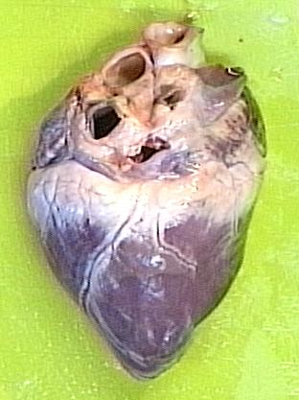

**Left**

**atrium**

**Right atrium**

**Right ventricle**

**Left ventricle**

# Opening the heart

Use a scalpel to make two incisions about 1 cm apart ⎯ one either side of the furrow that marks the division between the right and left ventricles (see image above). The incisions should be made so that they pass into the ventricles. From these initial incisions, the side of each ventricle can be cut from the heart.

# Internal Examination

Identify the inside of both atria and both ventricles.

1. Are the two sides of the heart completely separate?
2. Which part of the heart has the thickest wall? Explain why this area is thickest.
3. Why do you think the internal surface of the heart is bumpy rather than smooth?

Identify the following blood vessels: aorta, inferior vena cava, superior vena cava, pulmonary artery & pulmonary vein. Use a probe to determine which blood vessels connect to which chambers.

Examine the valves that are present. Identify the following valves: bicuspid, tricuspid & semilunar valves. The bicuspid and tricuspid are also called left and right atrioventricular valves, respectively.

1. In which direction does blood pass through the bicuspid valve?

Inside the ventricles you should observe some thin, white tendons called chordae tendinae. These tendons connect the valves to small protrusions of muscle tissue called papillary muscles.

1. What is the purpose of the tendons and the papillary muscles to which they are attached?
2. Use the names of the blood vessels, chambers and valves you have learned to propose a pathway for blood through the heart.
3. In which chambers would you expect to find oxygenated blood?
4. In which chambers would you expect to find deoxygenated blood?
5. What is a heart attack?
6. List some of the symptoms and possible causes of heart attacks?
7. Describe what happens during a coronary bypass.
8. What treatment do victims receive after a heart attack?

**Heart Rate**

Every time your heart beats, it forces blood into your arteries. This sends out a wave of increased pressure which you can feel as a pulse where the arteries are close to the surface. The two places where people usually take a pulse are at the neck (carotid artery) and the wrist (radial artery). Another method is to use a stethoscope to listen to, and count, the sounds that the heart makes.

### Measuring heart rate

To measure the radial pulse, let the subject sit with an arm resting in a relaxed manner on a bench. You can feel the radial pulse on the front of the wrist, approximately 2 cm from the crease where the thumb joins the wrist. Heart rate is measured in beats per minute (bpm).

Measure the heart rate four times with one minute breaks between measurements.

Repeat the experiment with the same person standing and then lying down. The subject should remain sitting, standing or lying for the entire time during which the four trials are completed. Record your results on the table below.

|  |  |  |  |  |  |
| --- | --- | --- | --- | --- | --- |
|  | Trial Number | | | | |
| **Position** | **1** | **2** | **3** | **4** | **Mean** |
| Sitting |  |  |  |  |  |
| Standing |  |  |  |  |  |
| Lying |  |  |  |  |  |

### Questions

1. Why did you use the same subject for all three positions?
2. What effect does body position have on heart rate?
3. Explain why body position affects heart rate. Consider the effect of gravity.
4. List any other factors that might affect heart rate?
5. The maximum effective heart rate for a human is about 200 bpm. Suggest why the heart becomes less efficient if the heart beats faster than about 200 bpm.
6. Define cardiac output and describe the influence of heart rate on it
7. Calculate the percentage increase in cardiac output if a person’s heart rate increases from 68 bpm to 155 bpm and their stroke volume changes from 78 mL to 85 mL during exercise.

**Blood Pressure**

The heart beats at a rate of approximately 72 beats per minute. Since the heart does not force out a steady stream of blood, a wave of increased pressure (the pulse) passes through the arteries with each beat. This high pressure wave of blood is called the systolic pressure and is produced during systole (or contraction) of the ventricles. During the pause between each beat, the blood pressure drops away considerably. This is referred to as the diastolic pressure.

The average blood pressure for a person aged 12 to 30 is approximately 120 systolic and 75 diastolic (often recorded as 120 over 75).

Blood pressure in arteries is measured using an instrument called a sphygmomanometer.

### Measuring Blood Pressure

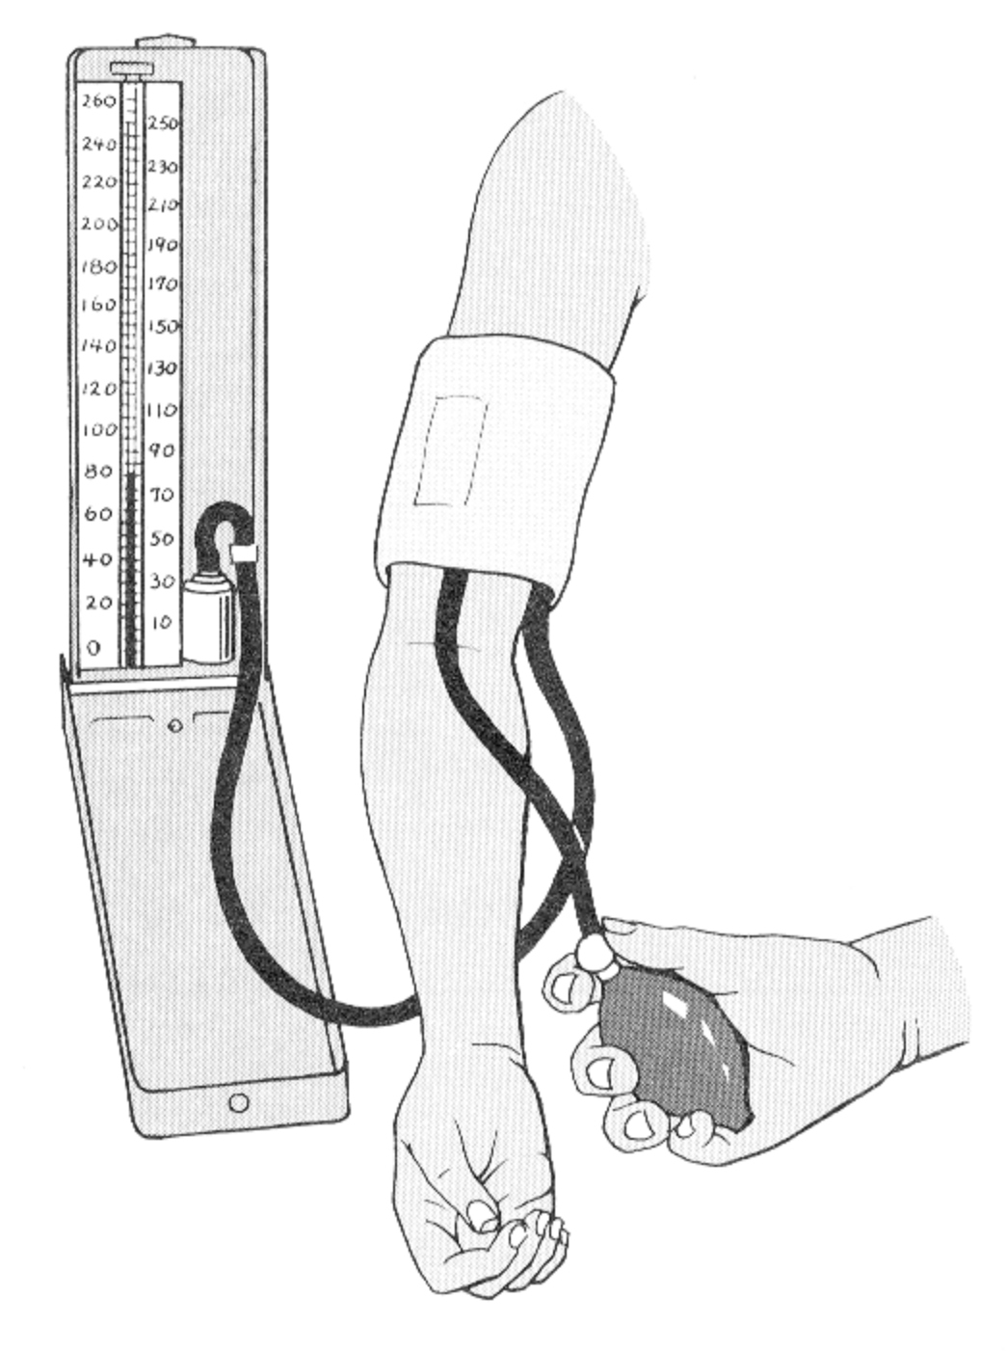The subject should sit with his left arm on a bench at about heart level. Fit the sphygmomanometer cuff as shown in the diagram to the right.

Read through the following instructions before you start.

1. Inflate the cuff to about 150 mmHg.
2. Place the stethoscope over the brachial artery at the elbow.
3. Slowly release the pressure in the cuff by unscrewing the valve.
4. Listen for a single intense sound (described as a ‘lub’). This is the sound of the pressure in the artery exceeding the pressure of the cuff. The pressure at which this occurs is the systolic pressure.
5. Continue to loosen the valve until you hear a continuous rushing sound. The pressure at which this occurs is the diastolic pressure.

### Questions

1. Explain why blood pressure is generally lower in females.
2. What is hypertension and why is it dangerous?
3. Atherosclerosis is a cardiovascular disease in which fatty substances deposit on the walls of arteries. What effect would these deposits have on blood pressure? What are the risk factors for atherosclerosis?
4. How long does a typical cardiac cycle last?
5. How long do the ventricles spend in contraction (systole)?
6. How long does the heart spend in diastole during a typical cycle?
7. There are four main valves in the heart. Describe what happens to each of these valves during ventricular systole.

**Electrocardiograms (ECG)**

The electrical current generated by cardiac muscle during contraction and relaxation spreads into the tissues surrounding the heart and is conducted through the body fluids. A small proportion of this electrical activity reaches the body surface, where it can be detected using electrodes. The record produced is called an electrocardiogram, or ECG.

Below is an example of a normal ECG

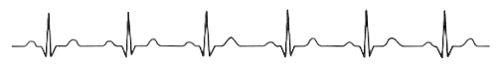

1. Re-draw part of a normal ECG in the space below and label the: P wave, QRS complex, and T wave.
2. Describe what is happening in the heart when each of these waves if formed. (For example: Are the ventricles contracting? Or are the atria contracting?)
3. Why is the P wave so much smaller than the QRS complex?

1. Why is there no wave representing the relaxation (or repolarisation) of the atria?

The ECG can be useful in diagnosing abnormal heart rates, arrhythmias and myopathies.

1. Explain how an ECG could be used to measure a person’s heart rate.
2. Below is a list of eight heart conditions and four abnormal ECGs. Research the cause and symptoms of each of these conditions and then match four of the conditions to their correct ECG. Write a sentence or two justifying your decision for each ECG.

* Tachycardia, Atrial fibrillation, Bradycardia, Ventricular fibrillation, Extrasystole (premature beat), Heart block, Atrial flutter, Myocardial infarction

|  |
| --- |
| Images\Respiratory, Digestive & Circulatory\Abnormal ECGs.jpg |
| Images\Respiratory, Digestive & Circulatory\Abnormal ECGs.jpg |
| Images\Respiratory, Digestive & Circulatory\Abnormal ECGs.jpg |
| Images\Respiratory, Digestive & Circulatory\Abnormal ECGs.jpg |

**Measuring Respiratory Volumes**

Physicians use vitalographs and spirometers to help diagnose and control lung diseases, such as asthma, bronchitis and emphysema.

# Aim

The purpose of this exercise is for you to determine your:

1. FVC (forced vital capacity)
2. FEV1 (forced expiratory volume in one second)
3. FEV1%

### Procedure

1. Follow the instructions for using the vitalograph.
2. Record your FVC, FEV1 and FEV1% in the table below. Repeat once more.

### Results

|  |  |  |
| --- | --- | --- |
| **Lung Measurement** | **Trial 1** | **Trial 2** |
| FVC |  |  |
| FEV1 |  |  |
| FEV1% |  |  |

### Questions

1. Explain what the following abbreviations mean:

FVC

FEV1

FEV1%

2. Does body size affect the FVC of a person? Explain.

3. During an asthma attack there is widespread narrowing of the bronchial airways. This is an example of an obstructive respiratory disease. The patient usually suffers from wheezing and breathlessness. What effect do you think an asthma attack would have on a patient’s FVC and FEV1?

4. The lung disease emphysema results in damage to the alveoli. Fibrous tissue replaces the alveoli and the lungs lose their elasticity. The patient, usually a smoker, develops increasing breathlessness and a cough. This is an example of a restrictive respiratory disease. What effect do you think emphysema would have on a patient’s FVC and FEV1?

**Lung Volumes**



From the above spirogram, calculate the following lung volumes:

Tidal Volume (TV) ___________

Residual Volume (RV) ___________

Expiratory Reserve Volume (ERV) ___________

Inspiratory Reserve Volume (IRV) ___________

Vital Capacity (VC) ___________